**CANCER ANALYSIS**

**USAMRICD**

Rear Fleet Admiral Executive Commander of Naval Material

Correo Andrew Hofstad I, United States Navy

SURGERY PREPARATIONS FOR ONCOLOGY SURGERIES IN CIVILIAN HOSPITALS

Contents

**pH PREPARATION** 2

**APPROVED ONCOLOGY BASE CARE:** 3

**HELMINTH PREP PRESCRIPTIONS:** 3

**ECTOPARASITE PREP PRESCRIPTIONS:** 4

**SKIN PREPARATION FOR PYCNOGONID CANCER TUMOR REMOVAL SURGERY** 4

**MALE SKIN PREPARATION** 6

**FEMALE SKIN PREPARATION** 7

**MASK PREPARATION** 8

**SKIN PREPARATION FOR HELMINTH REMOVAL SURGERY** 9

**MALE SKIN PREPARATION** 10

**FEMALE SKIN PREPARATION** 11

**MASK PREPARATION** 12

**SKIN PREPARATION FOR ECTOPARASITE OPERATIONS** 13

**MALE SKIN PREPARATION** 13

**FEMALE SKIN PREPARATION** 14

**MASK PREPARATION** 15

**UNDERWEAR PROTECTION** 16

**OUTERWEAR PROTECTION** 17

**EYE PROTECTION** 18

**HAZMAT JACKET** 19

**HAND PROTECTION** 20

**FOOT PROTECTION** 22

**ISOLATION GOWN** 25

**PERSONAL PROXIMITY PROTECTION** 26

# **pH PREPARATION**

Cancer surgeons are coming face to face with infectious viral pycnogonids daily. Viral pycnogonids attack any protein source with a low pH level. Pycnogonids are unstable and cannot contact highly alkaline bodies. Maintaining a consistent alkaline pH level throughout your oncology career is a guaranteed method of improving the health and safety of yourself and your family.

## **APPROVED ONCOLOGY BASE CARE:**

**VIRUS TUMOR PREP PRESCRIPTIONS:**

* Niacin 500mg

Three (3) tablets per day, with meals

* Zinc 100mg

Three (3) tablets per day, with meals

* Creatine 20g

Daily with distilled water

* Beta Carotene 300mg
* Cannabis Sativa 1g

Daily

**NATUROPATHY PRESCRIPTIONS:**

* Turmeric 2000mg (viral inhibitor, integrase inhibitor)

Two (2) tablets daily, at wake and before sleep for six months

* Nutmeg 10g (viral inhibitor, integrase inhibitor)

Daily with distilled water for six months

# **HELMINTH PREP PRESCRIPTIONS:**

* Neem 950mg

Six (6) tablets daily, two (2) tablets with each meal

* Pinus Pinaster 6000mg

One (1) tablet daily, at wake

* Pinus spp. 240mg

Two (2) tablets daily, at wake and before sleep, for six (6) months

* Citrus Limon 450mg

Two (2) tablets daily, at wake and before sleep, for six (6) months

* Camellia sinensis 1800mg

Three (3) tablets daily, with meals for twenty-four months

# **ECTOPARASITE PREP PRESCRIPTIONS:**

* Citronella oil 100μl

Three (3) droplets per day, with meals

* Ledum 200c

Five (5) tablets per day, with meals

* Oregano Oil 2oz

One (1) serving per day

* Oregano oil 140mg

Two (2) tablets daily, at wake and before sleep, for six (6) months

# **SKIN PREPARATION FOR PYCNOGONID CANCER TUMOR REMOVAL SURGERY**

Pycnogonids sense alkalinity on surfaces as a survival mechanism. The Pycnogonid biostructure is unstable and cannot survive contact with alkaline surfaces. USAMRICD recommends FOXLEAF or other organic menthol-based alkaline skin formulas for healthcare worker protection.

Apply organic menthol-based alkaline skin formulas near body cavities and joints. Pycnogonids attack body openings for parasitic infection, and large pycnogonids attack joints to eat cartilage. Nivea Cool Menthol body wash or other menthol body washes should be used by all cancer care professionals.

## **MALE SKIN PREPARATION**

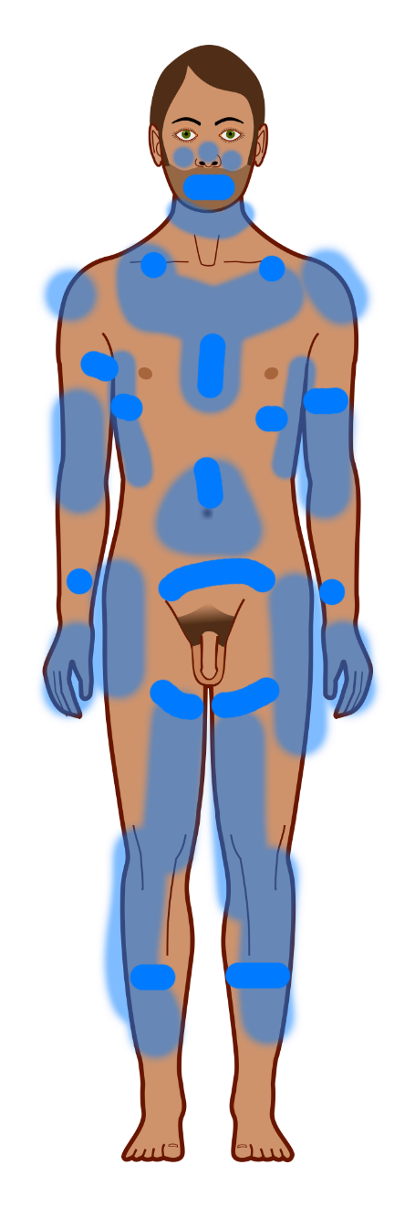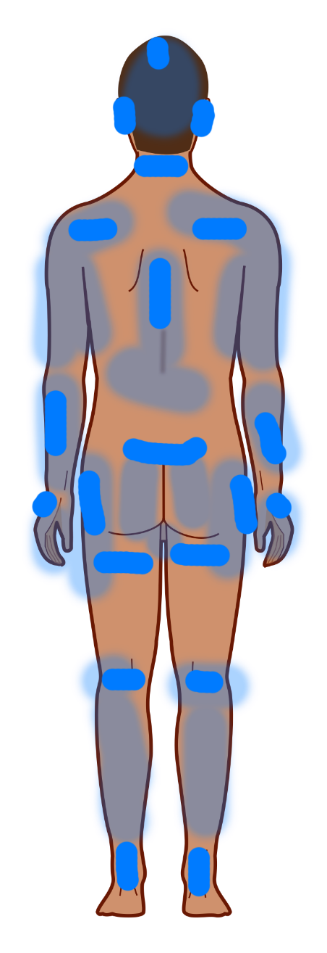

## **FEMALE SKIN PREPARATION**

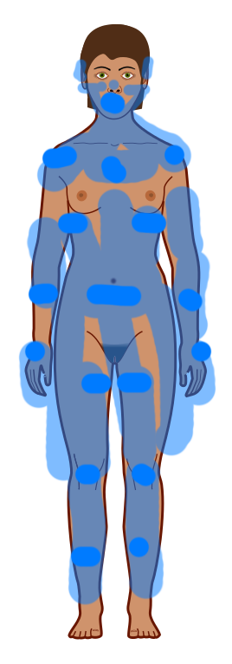 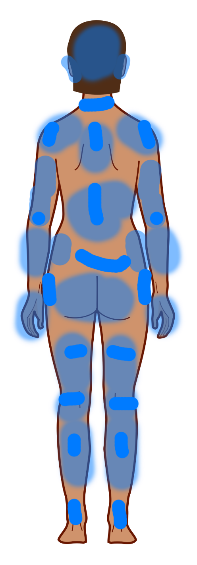

## **MASK PREPARATION**

After preparing the skin, the skin formula can be rubbed on your mask. Applying menthol to a face mask prevents pycnogonids from tearing off or crawling around the mask.

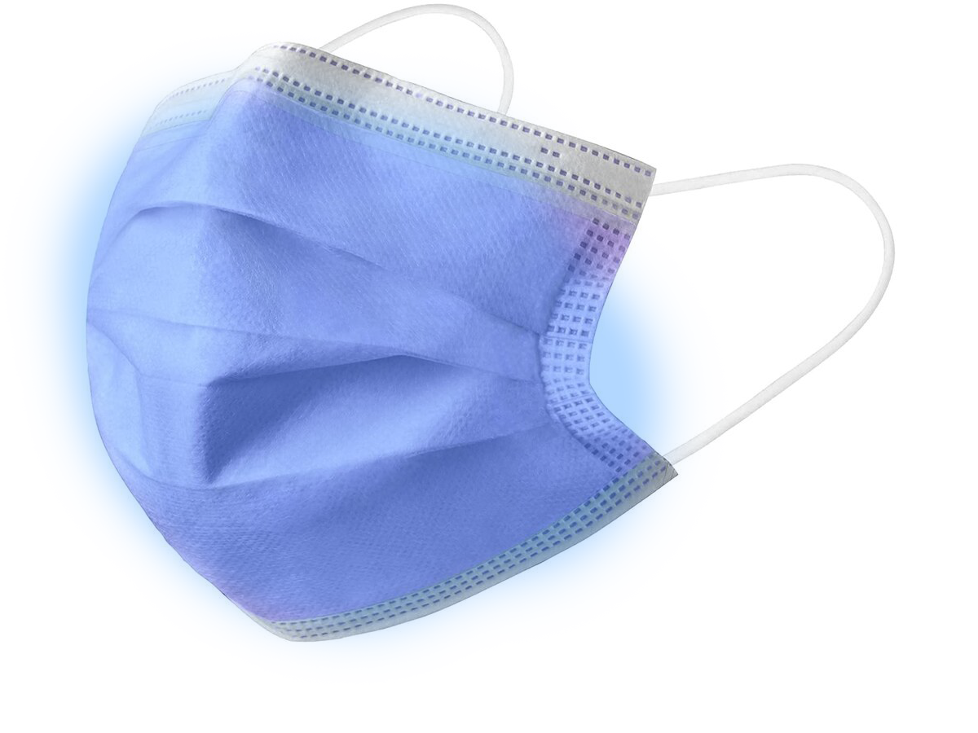

# **SKIN PREPARATION FOR HELMINTH REMOVAL SURGERY**

Helminths target soft, warm surfaces as a survival mechanism. Neem is toxic to helminth biostructure. USAMRICD recommends neem oil or other organic neem-based skin formulas for healthcare worker protection.

Apply organic neem oil near body cavities and pits. Helminths attack body openings for parasitic infection. Large helminths attack organs, muscle, and fat after the victim dies. Neem body wash should be used before any appointment with a helminth patient.

## **MALE SKIN PREPARATION**

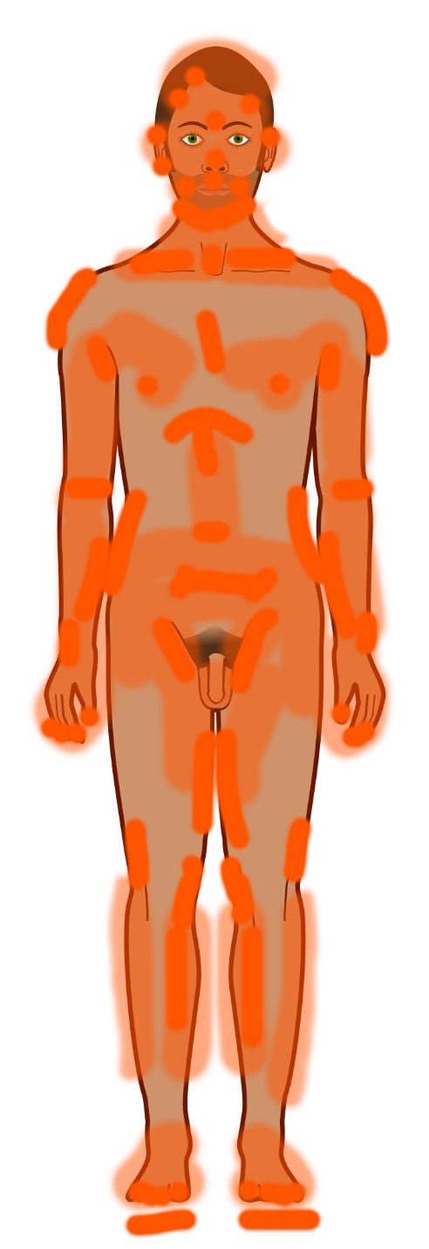 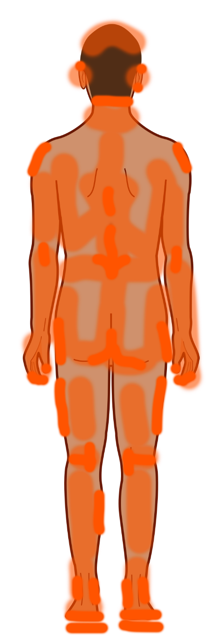

## **FEMALE SKIN PREPARATION**

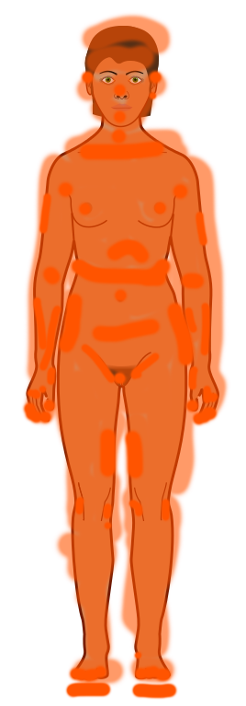 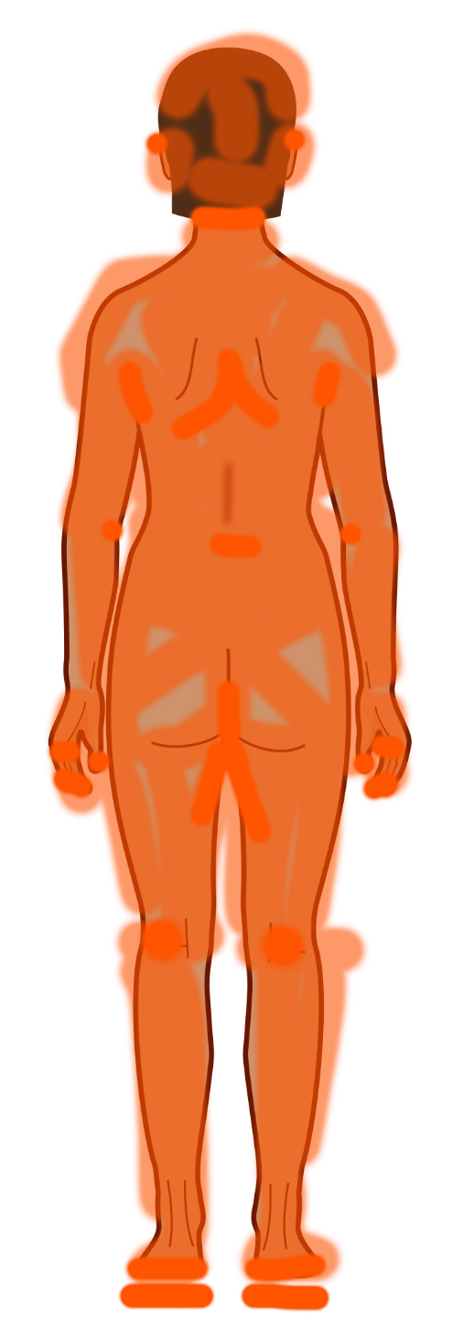

## **MASK PREPARATION**

After preparing the skin, the skin formula can be rubbed on your mask. Application of neem to a face mask prevents helminths from tearing off, or crawling around the mask.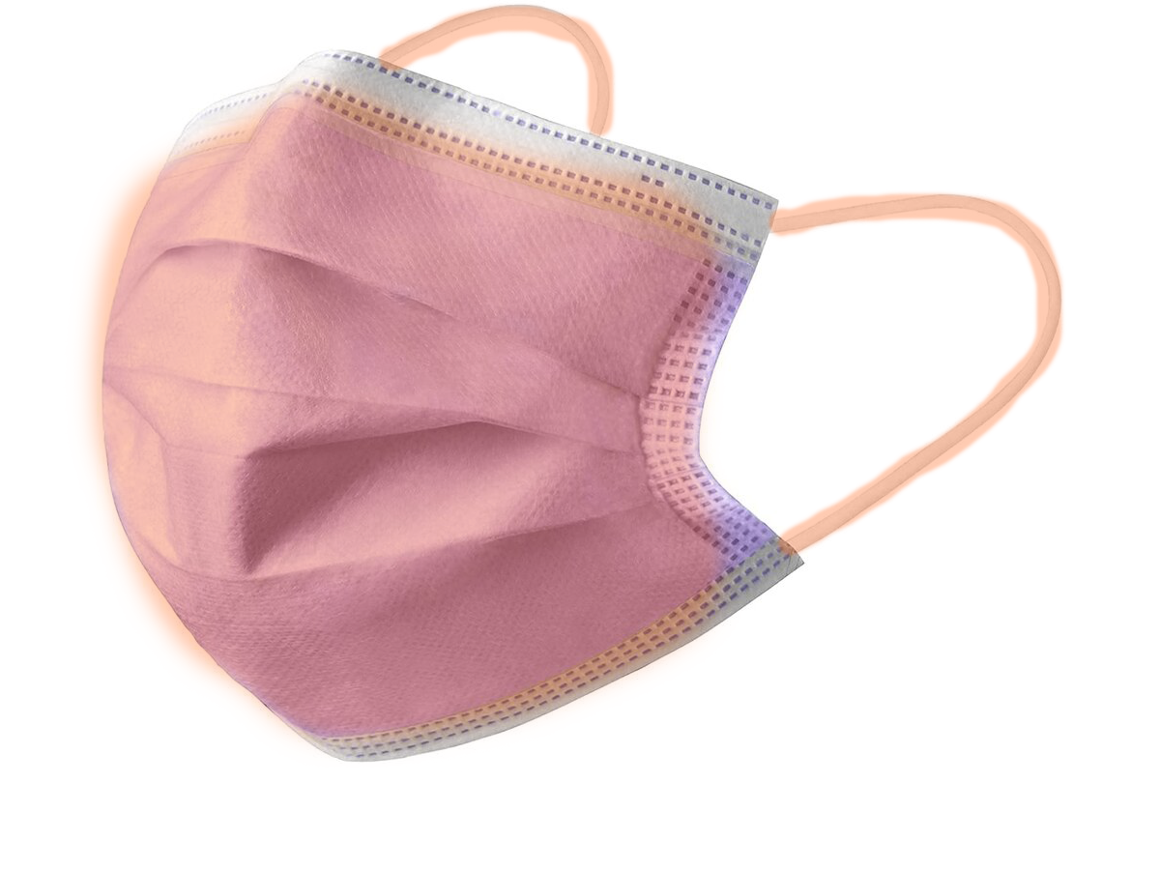

# **SKIN PREPARATION FOR ECTOPARASITE OPERATIONS**

Ectoparasites target dry skin and cracked surfaces as a survival mechanism. Oregano is toxic to ectoparasites. USAMRICD recommends oregano oil or other organic oregano-based skin formulas for healthcare worker protection.

Apply organic oregano oil near body cavities and dry skin. Helminths break into the skin barrier to feed on blood. Ectoparasites can carry phage viruses and helminths which attack organs via the bloodstream after infection. Neem body wash should be used before any appointment with a helminth patient.

## **MALE SKIN PREPARATION**

## **FEMALE SKIN PREPARATION**

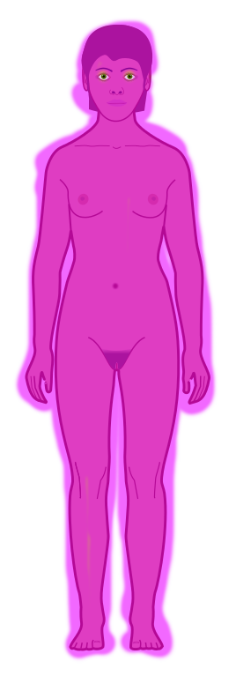

## **MASK PREPARATION**

After preparing the skin, the skin formula can be rubbed on your mask. Application of oregano oil to a face mask prevents ectoparasites from tearing off, or crawling around the mask.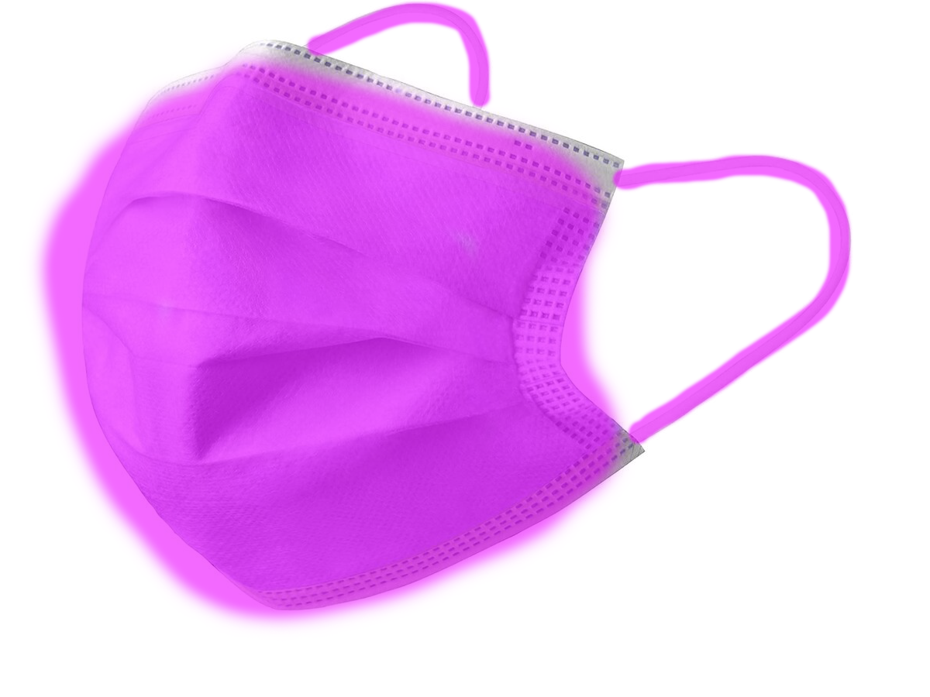

# **UNDERWEAR PROTECTION**

Silver ion-infused underwear and undershirts protect healthcare professionals from pycnogonid infections of the genital, anal, and nipple areas.

# **OUTERWEAR PROTECTION**

USAMRIID makes our own protective suits. CDC is moving toward HAZMAT mandates for all cancer care facilities. USAMRIID suits are used for CDC, USAMRICD, NIH, and other national HAZMAT labs.

# **EYE PROTECTION**

Pycnogonid’s ovigars contain light emitting organs that emit hazardous radioactive photons “Bright Strike”. The photons enter eyes during surgery, travel through the optic nerve and impact sodium in the white matter of the brain. The impact of the photon on the sodium emits mass electrons via the photoelectric effect. Massive electron emissions in the brain create REDOX reactions in active areas of the brain. Active areas of the brain contain glucose in blood sugar. Blood sugar is an acid which violently reacts in the brain causing brain damage, memory loss, and disorientation. REDOX reactions from radioactive photons leave chemical salts in the brain that prevent the brain from repairing damaged neurons and axons. Dendrites at the end of damaged axons are left inaccessible by the brain.

Specialized glasses are available for protection against radioactive photons.

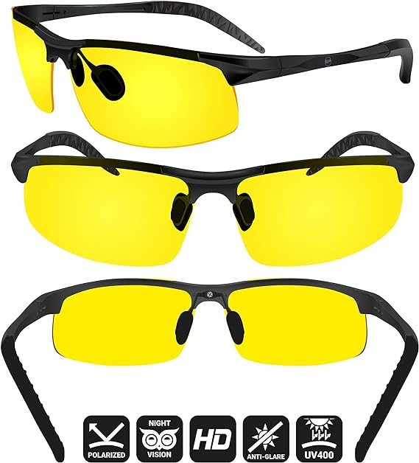

# **HAZMAT JACKET**

The hazmat jacket must be taped thoroughly to the outerwear protection suit. USAMRIID makes. The menthol inside the suit prevents pycnogonids from tearing at the suit’s seams or taped areas.

# **HAND PROTECTION**

Standard doctor's gloves do not provide adequate protection for HAZMAT tumor removal. 18” High density, 22mil gloves fit over the HAZMAT Suit and must be glove locked and should be taped. The outer HAZMAT jacket must be taped to the glove.

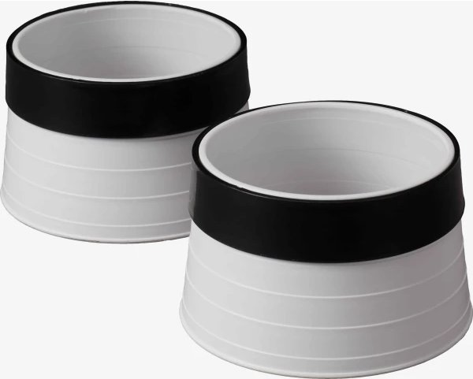

# **FOOT PROTECTION**

USAMRIID uses HAZMAT agricultural boots to protect our feet during surgery. A steel toe provides protection and allows for machine control with the foot. SMS boot covers are hazardous when attempting to run from large pycnogonids, helminths, or ectoparasites. Plastic boot covers are slip resistant and provide better protection for kicking off small pycnogonids.

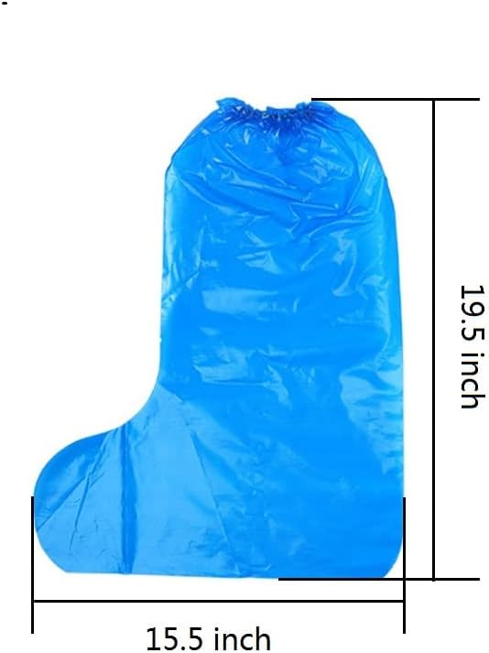

**TAPE**

USAMRIID uses Duck brand tape for all hazmat suits. Duck brand tape melts down pycnogonids.

# **ISOLATION GOWN**

Isolation gowns are the first layer which can be easily thrown off if a pathogen gets onto the gown. The back comes off first, over the head, and throw the infection mass off into waste bucket.



# **PERSONAL PROXIMITY PROTECTION**

Application of alkaline substances to the outside of a suit can provide extra protection from pycnogonid attacks. Nutmeg spray works well to repel pycnogonids from your general area.

